How to Bring Forth the Relaxation Response
Experience is the Basis of Knowledge
The following is the technique reprinted with permission from Dr. Herbert Benson's book
The Relaxation Response pages 159-161
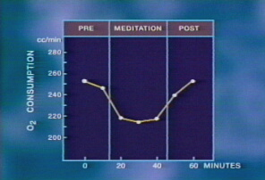

(1) A Quiet Environment
Ideally, you should chose a quiet, calm environment with as few distractions as possible. A quiet room is suitable, as is a place of worship. The quiet environment contributes to the effectiveness of the repeated word or phrase by making it easier to eliminate distracting thoughts.

(2) A Mental Device
To shift the mind from logical, externally oriented thought, there should be a constant stimulus: a sound, word, or phrase repeated silently or aloud; or fixing gazing at an object. Since one of the major difficulties in the elicitation of the Relaxation Response is "mind wandering," the repetition of the word or phrase is a way to help break the train of distracting thoughts. Your eyes are usually closed if you are using a repeated sound or word; of course your eyes are open if you are gazing. Attention to the normal rhythm of breathing is also useful and enhances the repetition of the sound or the word.

(3) A Passive Attitude
When distracting thoughts occur, they are to be disregarded and attention redirected to the repetition or gazing; you should not worry about how well you are performing the technique, because this may well prevent the Relaxation Response from occurring. Adopt a "let it happen" attitude. The passive attitude is perhaps the most important element in eliciting the Relaxation Response. Distracting thoughts will occur. Do not worry about them. When these thoughts do present themselves and you become aware of them, simply return to the repetition of the mental device. These other thoughts do not mean you are performing the technique incorrectly. They are to be expected."

(4) A Comfortable Position
A comfortable posture is important so that there is no undue muscular tension. Some methods call for a sitting position. A few practitioners use the cross-legged "lotus" position of the Yogi. If you are lying down, there is a tendency to fall asleep. As we have noted previously, the various postures of kneeling, swaying, or sitting in a cross-legged position are believed to have evolved to prevent falling asleep. You should be comfortable and relaxed.

